**Gold Price Prediction Model using Machine Learning**

**Aggrima Arora**

Summary:

The "Gold Price Prediction Model using Machine Learning" project aims to develop an effective and accurate model for predicting the price of one of the most precious metal - Gold. The report on gold price prediction utilizing machine learning (ML) techniques presents a comprehensive analysis of historical gold price data and the application of ML algorithms for forecasting future price trends. The study employs advanced data analytics and predictive modelling to enhance the accuracy of gold price predictions.

Initially, the report delves into the collection and preprocessing of extensive datasets, encompassing factors such as historical gold prices, economic indicators, and geopolitical events. The utilization of machine learning algorithms, including regression models, decision trees, and neural networks, is then outlined to discern patterns and correlations within the data. The machine learning models are trained and validated using historical data, allowing for the identification of key features and factors influencing gold prices.

The report evaluates the performance of various ML algorithms, assessing their predictive capabilities and highlighting the most effective models in capturing the complexities of gold price dynamics. Furthermore, the study discusses the incorporation of real-time data and external variables to enhance the robustness of the ML models. The report concludes by presenting the predicted gold price trends and assessing the accuracy of the machine learning-based forecasts compared to traditional methods.

Overall, the report provides valuable insights into the integration of machine learning in predicting gold prices, offering a data-driven approach that can aid investors, policymakers, and industry stakeholders in making informed decisions in the dynamic and complex gold market.

Background:

Gold symbolized by the chemical symbol Au on the periodic table. It boasts a distinct yellow hue and remarkable resistance to corrosion, making it highly sought after for various purposes. Renowned for its malleability and ductility, gold can be crafted into intricate jewellery, coins, and ornamental objects.

Beyond its aesthetic appeal, gold holds a unique status as a store of value and a symbol of wealth across different cultures. Its historical significance as a currency and its role in shaping economies have established gold as a timeless asset, often considered a safe haven in times of economic uncertainty. Gold has captivated humanity for centuries, revered for its lustrous beauty and enduring value.

Gold price predictions serve different purposes and benefit different stakeholders. For investors, accurate forecasts facilitate informed decision-making and support risk management and portfolio diversification. Individuals and financial planners use predictions to preserve wealth, capitalizing on gold's historical role as a store of value. Economic analysts and policymakers view the gold price as an indicator of overall economic conditions that influences monetary policy. In business, mining companies use forecasting to optimize production and maximize profitability, while industries that rely on gold integrate forecasting into their supply chain management. Central banks consider gold price forecasts when making policy decisions, and traders use them to identify profit opportunities.

Overall, gold price forecasting plays a critical role in the stability of the global economy, providing insights that range from mitigating risks, hedging market volatility, and assessing market sentiment and confidence.

Objectives:

- Facilitate informed decision-making to effectively manage investment risks.

– Helps you diversify your investment portfolio by taking advantage of gold's unique behaviour compared to other financial assets.

– Assists personal and financial planners with long-term asset preservation.

– Provides insight into general economic trends and serves as an indicator of economic stability and inflation expectations.

– Optimize investment strategies for gold mining operations and mining companies.

– Central banks take the gold price into account when formulating economic policy and form monetary policy.

– Helps companies in the gold industry plan and mitigate supply chain risks.

– Allows traders to identify short-term profit opportunities based on expected gold price movements.

– Contributes to the assessment of global economic stability by reflecting market sentiment and confidence.

– Acts as insurance for investors seeking stability and protection against market fluctuations.

– Reflects market sentiment and confidence levels and influences macroeconomic assessments.

Literature Review:

The literature on gold price forecasting includes various studies that use different methods and data sources to predict the future trends of this precious metal. Many researchers have studied applying traditional econometric models such as autoregressive integrated moving average (ARIMA) and vector autoregressive (VAR) to historical gold price data to understand the temporal patterns and Gaining insight into periodic behaviour.

Additionally, machine learning (ML) techniques have gained traction in recent years, leveraging algorithms such as support vector machines (SVMs), neural networks, and ensemble techniques to capture the complex nonlinear relationships inherent in gold price dynamics. Research is being done. Several scholars have intensively studied the influence of macroeconomic indicators on the price of gold, examining the influence of factors such as interest rates, inflation, and exchange rates. These macroeconomic studies contribute to a comprehensive understanding of the external variables that influence gold price movements.

Geopolitical events and market sentiment have also been identified as key drivers of gold prices, prompting researchers to incorporate sentiment analysis and event-driven approaches into their predictive models. Additionally, research has extended beyond univariate models to multivariate analysis, integrating a wider range of information into predictive frameworks.

Exploring real-time data such as social media sentiment and news analytics has emerged as a current trend to improve predictive accuracy. Research examining the impact of gold price forecasting on investment strategies, risk management, and economic policy decisions further highlights the practical implications of predictive models in finance. Despite progress, challenges remain, such as the inherent volatility and nonlinearity of gold prices.

Researchers continue to explore innovative ways, improve existing models, and integrate alternative data sources to address these challenges. Synthesizing insights from this diverse literature forms the basis of the current report, which incorporates cutting-edge machine learning techniques and a comprehensive analysis of relevant macroeconomic and geopolitical factors to advance The aim is to contribute to the gold price prediction environment.

Data Collection and Data Preprocessing:

This section details the data sources used, including historical gold prices, macroeconomic indicators, and relevant external variables. The preprocessing steps involve handling missing data, scaling features, and creating a suitable dataset for training the Random Forest Regressor. A Random Forest Regressor is a machine learning algorithm that belongs to the ensemble learning category. Ensemble learning involves combining the predictions of multiple individual models to improve overall predictive performance and generalization. In the case of regression tasks, where the goal is to predict a continuous output, the Random Forest Regressor builds a collection of decision trees and averages their predictions.

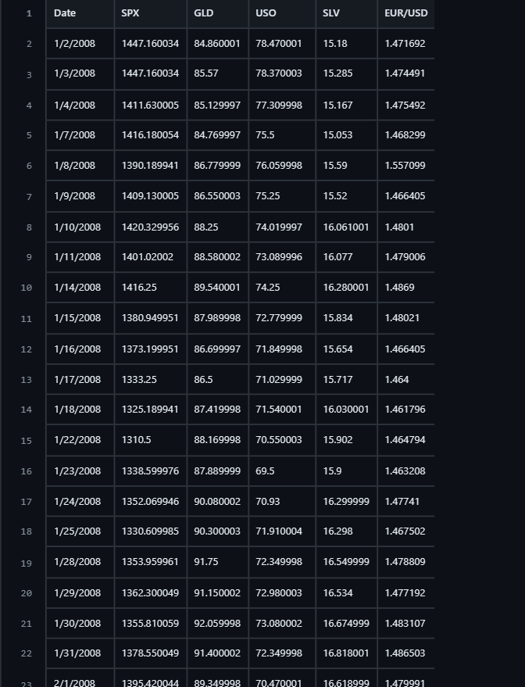

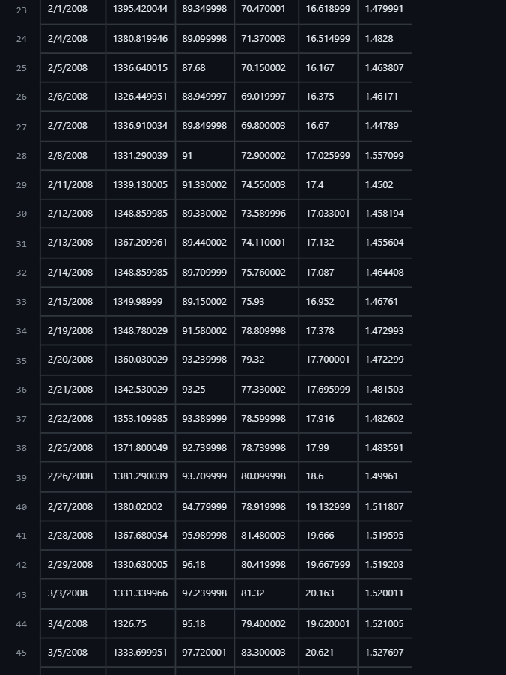

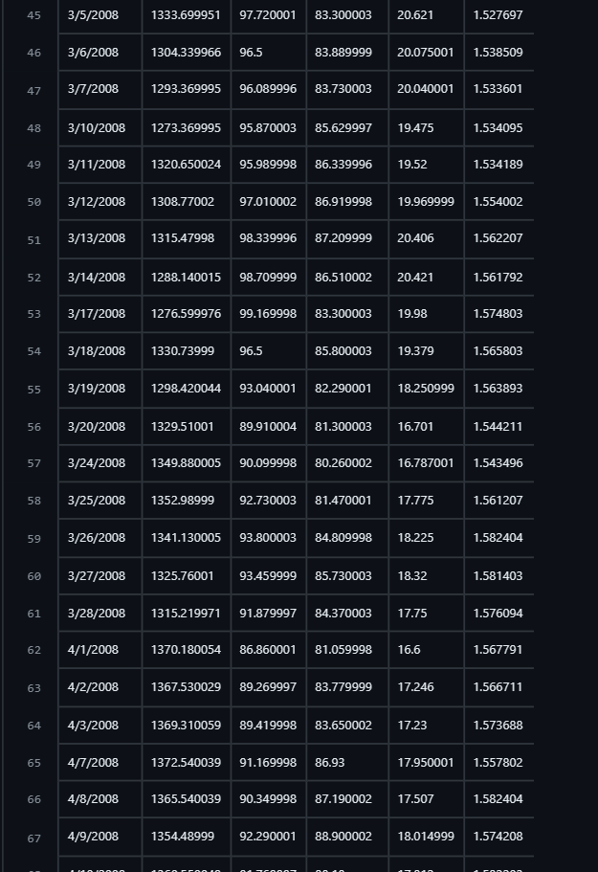

Model Selection:

Several machine learning algorithms, including logistic regression, decision trees, and support vector machines, were evaluated for their effectiveness in the prediction. The selection criteria considered accuracy, precision, recall, and interpretability.

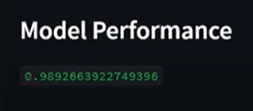

Model Training and Evaluation:

Details the training of the Random Forest Regressor on the prepared dataset and the evaluation metrics used to assess the model's performance. This section may include discussions on Mean Absolute Error (MAE), Mean Squared Error (MSE), and R-squared to quantify prediction accuracy.

Results and Findings:

Presents the results of the gold price predictions, highlighting the model's performance on both training and testing datasets. Key findings, such as influential features and insights into gold price dynamics, are discussed.

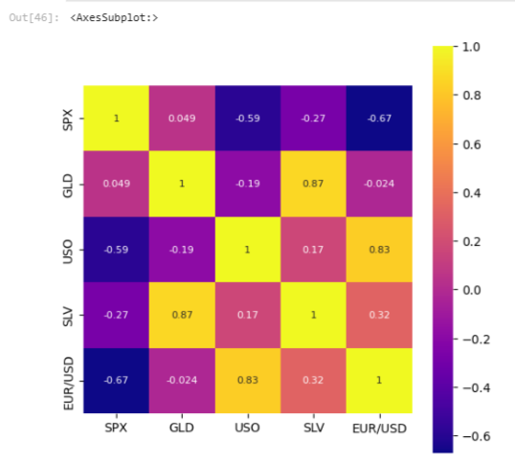

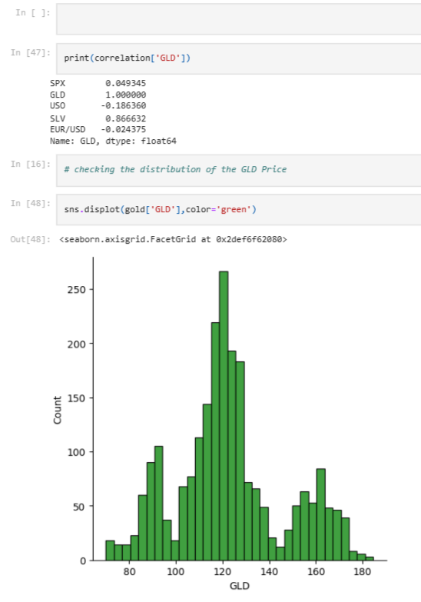

Comparison with Traditional Methods:

Compares the Random Forest Regressor's performance with traditional econometric models or other machine learning algorithms commonly used for gold price prediction.

Conclusion:

Summarizes the report's key findings, emphasizing the efficacy of the Random Forest Regressor for gold price prediction. The conclusion may also provide practical implications for investors, policymakers, and industry stakeholders.

Screenshots:

